**Final Year Physics Project – Final Report**

University Registration/ Library Card No. (Do not put your name here)

*Department of Physics, University of Warwick, Coventry CV4 7AL, United Kingdom*

(Dated: January 23, 2015)

This is where you should put your abstract. You should try and make your abstract as concise as possible giving the general aims of the investigation as well as the major results. The abstract should be around 50 - 100 words and be able to be read in isolation.

This file provides the basic word template for the final year Physics project final report required for PX402 and PX319 at the University of Warwick. Any definition regarding the size, font size, margin size, etc. should not be changed. However, you can use either single or two column format.

1. **Introduction**

The introduction is where you will discuss the overall aims and objectives of your investigation as well giving a general picture of why it is important. You will most likely have to link it back to previously published literature. The references should be to literature journals or published books. References from websites should only be used sparingly and if possible the information from websites should be traced back to the original source.

1. **Theory**

The theory section is where you discuss the underlying physics of your project. If you are doing an experimental project, this might include the theory of the experimental technique or data analysis methods you are using, while for a theoretical technique it could be the theoretical approach you are using and developing. For computational, it will ideally be the underlying theory relating to the Physics problem for which your program is being written. Regardless of type of project, there is a good chance your theory section will contain equations. For short equation you can include them in the actual text *F = ma* or if they are larger or more important you might want to give the more space:

$$F\left(T\right)=U\left(T\right)-T\int_{0}^{∞}{d\overset{⃑}{T}\frac{U\left(\overset{⃑}{T}\right)-U\left(0\right)}{U\left(\overset{⃑}{T}\right)}} (1)$$

1. **Results**

The results section is where you’ll make a summary of your work done during Terms 1 and 2.

1. **Figures**

Figures are a common gripe with many people who use word. There are however ways to deal with them and ensure they don’t jump off the page!

When wrapping text around figures, it is often the case the figure will not stay where you want them to. You can work around this by anchoring the image to a paragraph.

To be able to anchor the image, go to **File**, **Options**, **Display** and then tick **Object anchors**. Keep in mind that the anchor symbol will only display when you’ve wrapped the text around the image, and only when you have the image selected.

|  |
| --- |
| **Style Regulations** |
| 12 pt font size for main text, including references |
| 1.5 Line spacing |
| All margins 2.5 cm |
| Pages numbered |
| The use of narrow fonts such as Arial Narrow is forbidden |
| Section headings are 16 pt, subsection headings are 14 pt |

Simply move the anchor to the paragraph you wish to anchor it to. The image will now remain in the same position with regards to the paragraph you have anchored to. So anything added after the paragraph in question will wrap around the image without moving it. Although bare in mind that if you add something before the anchored paragraph will cause the image to shift as well.

1. **Conclusion**

You should be drawing conclusions as you discuss your results but this section acts as a summary. Many people will read the conclusion first to get a feel for the quality of the results, etc. So this can be an important section. Finally if you have any questions please feel free to contact me at the following e-mail address:

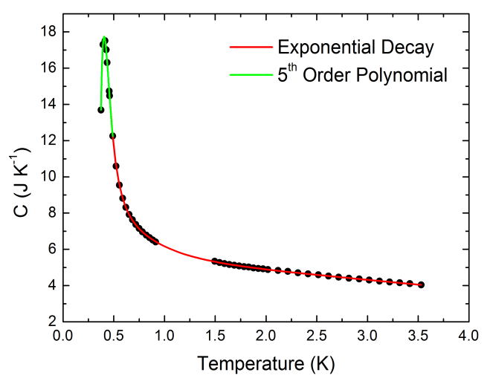

Fig. 1 This is an example figure.

[D.Brunt@warwick.ac.uk](mailto:D.Brunt@warwick.ac.uk)

**References**

[1] A. Author, B. Author and C. Athour, Journal **vol.,** page (year).

[2] D. Author *et al.,* Journal **vol**, page (year).